The Arnprior Silver Dollar
The Arnprior silver dollar is not a separate coin type with a different face value — it’s a collectible variety of the Canadian silver dollar struck by the Royal Canadian Mint (RCM). These dollars are the same 80% silver, 20% copper coins issued in the early to mid-20th century, featuring the classic Voyageur canoe design on the reverse. (Cavac)
What makes certain dollars “Arnprior” is a distinct die variation — specifically how many water lines appear in front of the canoe.

How the Name “Arnprior” Came About
In December 1955, the RCM struck about 2,000 silver dollars for a company in Arnprior, Ontario. These coins were found to have only 2½ water lines to the right of the canoe instead of the usual four. Collectors adopted the name “Arnprior dollar” after the town where the coins were first recognized, and the name has since been used to describe similar short water line varieties on other dates. (Wikipedia)
Arnprior vs. Regular Silver Dollar
The main difference between a regular silver dollar and an Arnprior variety lies on the reverse side (the canoe side):
Water Lines
- Regular silver dollar: Shows four full water lines in front of the canoe. (Cavac)
- Arnprior variety: Shows 2½ (or sometimes 1½) water lines — the bottom water line is absent and the middle may be partial. (Cavac)
A helpful way to see this is with a magnified comparison showing exactly where to count the lines:

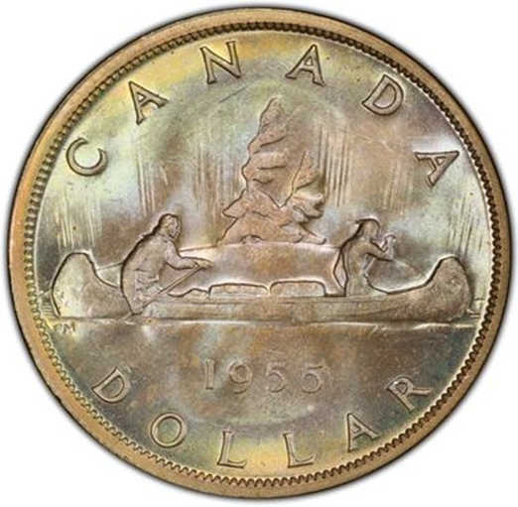
Example of a silver Arnprior dollar where the lower lines have been partially or fully polished away on the reverse.
To count them, focus on the area to the right of the canoe’s bow — the shallow horizontal lines represent the water. Compare how many distinct lines reach back toward the canoe.
Other Markers That Collectors Watch
While water lines are the key feature, some Arnprior silver dollars — especially the 1955 issues — may also show a die break on the obverse (front): a tiny raised line joining the T and I in the word “GRATIA.” Collectors often consider this a bonus feature for value, though not all short water line coins have it. (Cavac)

Why Arnprior Varieties Matter
Even though these dollars are still legal tender with the same silver content as regular dollars, the rarity of certain water line configurations can make them more desirable to collectors. Coins with:
- Very short water lines (like the classic Arnprior pattern),
- Minimal die wear, and
- Special obverse features (like a die break),
can sometimes command higher prices than common examples.

Summary of Key Differences
Feature | Regular Silver Dollar | Arnprior Variety
Water Lines on Reverse | Four full lines | 2½ or 1½ lines
Origin of Name | None | Linked to Arnprior, Ontario shipment
Collector Interest | Standard | Higher due to rarity
Die Break (Obverse) | Typically none | May be present on some (e.g., 1955)

References
- Canadian silver dollar die varieties and water lines — technical explanation of how die polishing created short water line variants and how the Arnprior term became attached. (Cavac)
- Arnprior origin story and collector history — narration of how these coins were linked to Arnprior shipments and how collectors use the term. (Wikipedia)
- Collector identification details — discussion of classic Arnprior features like 2½ water lines and optional die break features. (Collectors Universe)

