Wooden Money: A Fun and Fascinating Corner of Numismatics
By Jim Austin

What Is Wooden Money?
When most collectors think about money, they picture coins or paper notes printed by a government.
When people hear the term wooden money, the first reaction is often a chuckle. After all, money is supposed to be metal or paper, right? But wooden money has been part of North American collecting culture since at least 1931, and it holds an important place in both numismatics and exonumia.
Wooden money usually refers to wooden tokens or wooden nickels, often round but sometimes square or unusually shaped, that were issued as souvenirs, advertising pieces, emergency money, commemorative items or local trade tokens. They were never legal tender issued by governments, but they were often accepted locally or handed out to mark special occasions.
Early wooden tokens were usually imprinted with the denomination of five cents. This gave rise to the famous expression "Don't take any wooden nickels.", however, the denominations could also include 25¢, 50¢ and $1 and anything else the issuer decided.
For collectors who enjoy history, storytelling, and variety, wooden money offers something different: history you can hold, unusual designs, and a collecting field that is still affordable and approachable.

A Brief History of Wooden Money
Wooden money has its roots in hard times and creative marketing.

Early Emergency Issues
The earliest and most famous period for wooden money was during the Great Depression of the 1930s in the United States. Cash shortages forced towns, merchants, and local organizations to get creative. In some cases, wooden tokens were issued as emergency scrip, redeemable for goods or services locally.
These pieces weren’t meant to last forever. Wood was cheap and readily available, making it a practical solution when metal tokens were too expensive to produce.
Canada was a little slower to produce wooden tokens, not appearing until the around the early 1950’s

Souvenirs and Advertising
Eventually, wooden nickels became popular as advertising giveaways. Businesses handed them out to promote stores, fairs, expositions, and tourist attractions. The term wooden nickel itself became slang for something of little value—but collectors today know better.

Expositions and World’s Fairs
Wooden money was especially popular at World’s Fairs, exhibitions, and centennial celebrations. These tokens were sold or given away as keepsakes, often featuring local landmarks, dates, or slogans.

Modern Issues
Wooden money didn’t disappear after the Depression. In fact, it continues to be produced today for:
- Coin clubs
- Numismatic conventions
- Anniversaries
- Fundraisers
- Tourist attractions
Modern wooden tokens often feature laser engraving, color printing, and with more elaborate designs than their early counterparts.

Shapes and Sizes: More Variety Than You Might Expect
While many people imagine wooden money as simple round discs, the reality is much more interesting.

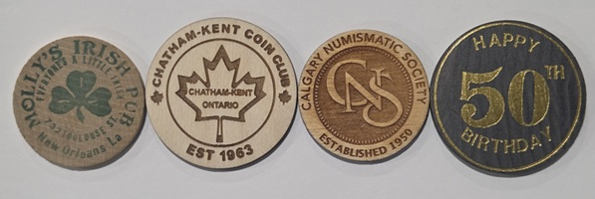
Round Tokens
The most common shape is round, typically the size of a nickel, quarter, or silver dollar. These often closely resemble coins and are popular with traditional coin collectors.

Photo courtesy Jim Austin

Square and Rectangular Pieces
Square wooden tokens are less common but highly collectible. Rectangular pieces were often used as admission tokens or advertising coupons or promotional pieces.
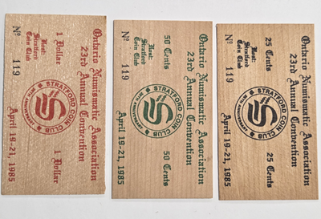
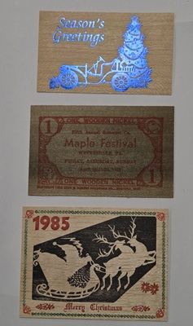
Photo courtesy Jim Austin Photo courtesy Jim Austin

Unusual and Novelty Shapes
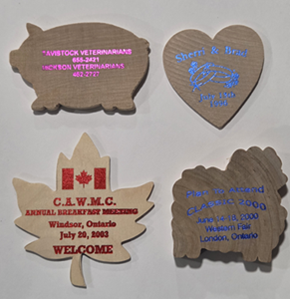
Some issuers got creative, producing tokens shaped like:
- Shields
- Houses
- Trees
- Animals
- State or Provincial outlines
- Hearts
These novelty shapes are especially popular with thematic collectors.

Photo courtesy of Jim Austin

How Wooden Money Was Made
Early wooden money was usually made from birch, maple, or other light woods. The designs were applied in several ways:
- Ink stamping (most common for early pieces)
- Burned or branded designs
- Pressed or Carved lettering
- Modern laser engraving common after the 1970’s
Because wood is an organic material, condition can vary greatly. Cracks, warping, stains, and fading are all part of the challenge—and charm—of collecting wooden money.

What Do Collectors Look For?
Just like coin collecting, wooden money collectors focus on several key factors.

Condition
Sharp lettering, minimal cracking, and legible printing are desirable. However, minor flaws are expected, especially on older pieces.

Age
Great Depression-era wooden money is especially sought after, particularly pieces dated between 1930 and 1939.

Scarcity
Some wooden tokens were produced in small quantities for local events and were never meant to survive. These can be surprisingly rare today.

Design and Theme
Popular themes include:
- Railroads
- Banks
- World’s Fairs
- Coin clubs
- Political campaigns
- Tourist attractions

Collecting Themes and Specialties
One of the joys of collecting wooden money is the ability to specialize.
Some popular collecting themes include:
- Depression-era wooden money
- Canadian wooden tokens
- Coin club issues
- Exposition and fair souvenirs
- Advertising wooden nickels
- Holiday or anniversary tokens
- 1967 Centennial Wooden Money

Many collectors enjoy mixing wooden money into their broader exonumia or token collections.

Storage and Care
Because wooden money is more fragile than metal, storage is important.
Best practices include:
- Store in a dry environment
- Avoid high humidity and temperature changes
- Use archival-quality holders or envelopes
- Never seal in airtight plastic if moisture is present
- Never clean wooden tokens. Cleaning can remove ink, damage the surface or lower collector value

Values and Affordability
One of the biggest appeals of wooden money is its affordability. Many pieces can still be found for just a dollar. Scarcer or historically significant examples can sell for more, but overall, it remains a budget-friendly collecting area making this an excellent entry point for new collectors.
Values depend on:
- Rarity
- Condition
- Demand
- Historical significance

Why Wooden Money Deserves a Place in Your Collection
Wooden money captures moments in local history that metal coinage never recorded. From small towns and fairs to national celebrations, these pieces reflect community pride, creativity, and resilience. They also offer a fun break from traditional coin collecting.
Whether you’re a beginner looking for something different or a seasoned collector exploring exonumia, wooden money is a field worth exploring.

