Canadian 50 Cent Coin: 1982 Large vs. Small Bead Varieties
  - By Jim Austin

Introduction
The Canadian 50 Cent coin from 1982 is a fascinating piece for numismatists, particularly because it features two distinct varieties: the large bead and the small bead versions. These differences are not merely cosmetic but also offer insights into the intricacies of coin minting processes. This article aims to provide a comprehensive analysis of these varieties, focusing on the key distinguishing features.

Queen's Hair Detail
One of the most noticeable differences between the large and small bead varieties is the detailing in the Queen's hair. On the small bead variety, the hair is more intricately detailed, with finer lines and a more textured appearance. This added detail gives the Queen's portrait a more lifelike and three-dimensional quality. In contrast, the larage bead variety has less detailed hair, appearing smoother and less pronounced. This difference can be attributed to the different dies used in the minting process.

Jewels on the Tiara
Another significant difference can be observed in the jewels at the very front of the Queen's tiara. For the large bead variety, there are two equal-sized jewels positioned on top of each other. This symmetrical arrangement gives the tiara a balanced and elegant look. On the other hand, the small bead variety features one larger jewel on top of a much smaller one. This asymmetrical design is a key identifier for distinguishing between the two varieties. Collectors often use this feature as a quick reference when sorting through their collections.

Design of the Bust
The bottom of the Queen's bust also varies between the two bead varieties. In the large bead version, the bottom of the bust is rounded, giving it a softer and more flowing appearance. The small bead variety, however, features a pointed bottom on the bust. This pointed design adds a certain sharpness and contrast to the coin's appearance, making it easily distinguishable from the large bead variety.

Bead Size and Distribution
The size and distribution of the beads around the edge of the coin are the most defining characteristics that separate the two varieties. The large bead variety, as the name suggests, features larger beads that are evenly spaced around the coin's perimeter. These larger beads create a bold and striking border that frames the coin's design elements effectively. In contrast, the small bead variety has smaller beads that are more closely spaced. This denser arrangement of smaller beads gives the coin a more delicate and intricate border.
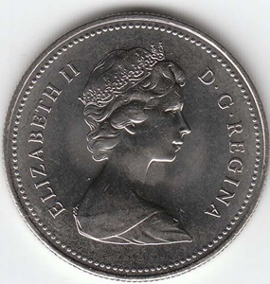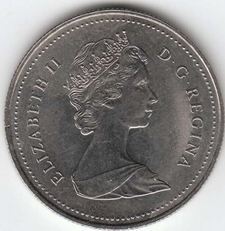
Large Bead Small Bead

Historical Context
Understanding the historical context of the 1982 Canadian 50 Cent coin adds another layer of appreciation for these differences. The early 1980s were a time of technological advancements in coin minting, with new techniques and tools being introduced. The large and small bead varieties reflect these changes and the experimentation that took place during this period. Collectors value these coins not only for their aesthetic differences but also for their historical significance.

Collecting Tips
For those interested in collecting the 1982 Canadian 50 Cent coin, there are a few tips to keep in mind. First, always examine the Queen's hair and the jewels on the tiara under good lighting and with a magnifying glass. These features are the easiest to spot and can quickly help you identify the variety. Next, pay attention to the bottom of the bust, as this feature is another clear indicator. Lastly, the bead size and distribution around the coin's edge should be carefully observed. Keeping these tips in mind will help you build a well-curated and authentic collection.

Conclusion
The 1982 Canadian 50 Cent coin is a remarkable example of numismatic variety and historical significance. The large and small bead varieties offer collectors a unique opportunity to appreciate the subtle differences in design and detail that make each coin special. By understanding and recognizing these differences, collectors can deepen their appreciation for the art and science of coin minting.
In summary, the next time you come across a 1982 Canadian 50 Cent coin, take a closer look at the Queen's hair, the jewels on the tiara, and the bottom of the bust. These features tell a story of a time when coin design was evolving, and they serve as a testament to the craftsmanship and artistry that go into creating currency. Happy collecting!

