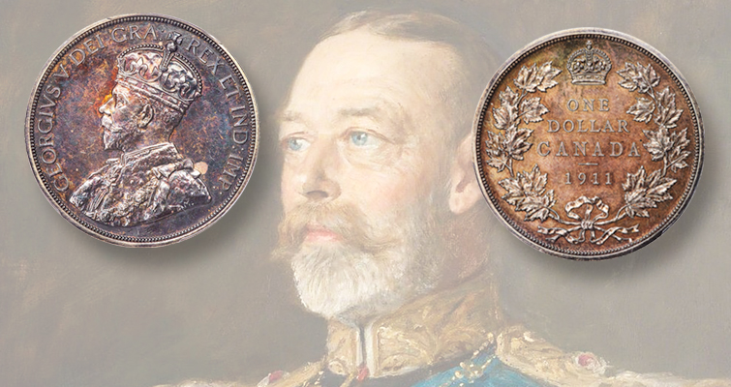

The History of the Canadian 1-Dollar Coin
By Jim Austin
A journey from early experiments and silver dollars through to the iconic Loonie
The Canadian one-dollar coin has a rich and fascinating history, reflecting changes in economy, technology, and national identity. From early patterns and silver issues to modern circulation coins, this article traces the evolution of Canada’s dollar coin up to the present day — including the rare 1911 silver dollar and the beloved Loonie introduced in 1987.

Early Currency and Pre-Mint Canadian Dollars
Colonial Currency and Foreign Coins
Before Canada had its own widely accepted coinage, a variety of foreign coins circulated in British North America — including Spanish, French, Portuguese, Dutch, German, and U.S. coins — because local supplies of British currency were limited. Merchants and banks often accepted this mix due to practical necessity. (bankofcanadamuseum.ca)
Decimal System and Early Canadian Coinage
The Province of Canada adopted a decimal currency system in 1858 — replacing the British pound with the Canadian dollar — and began issuing official provincial coins. Other provinces followed with their own issues (e.g., Nova Scotia, New Brunswick, and Newfoundland). However, a standard federal dollar coin would not come for many decades. (bankofcanadamuseum.ca)

The 1911 Silver Dollar Pattern
One of the earliest attempts by Canadian authorities to strike a one-dollar coin occurred in 1911. Tools were prepared and trial coins were struck — including two in silver and one in lead — but the Canadian government changed shortly thereafter and cancelled the planned issue. As a result, these pieces were classified as pattern coins and were never released into general circulation. (bankofcanadamuseum.ca)
Because only three examples were struck — two in silver and one in lead — the 1911 pattern dollar is one of the rarest and most coveted Canadian coins, nicknamed among collectors as “The Emperor of Canadian Coins.” (bankofcanadamuseum.ca)

The First Circulating Canadian Dollar: 1935 Silver Dollar
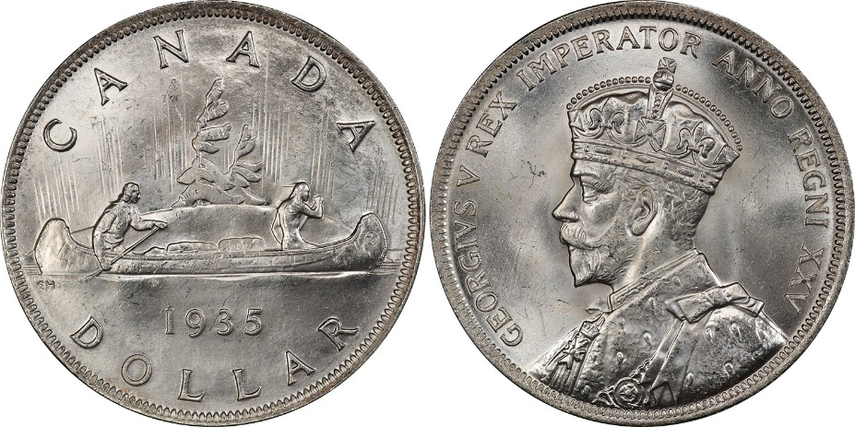
The first official Canadian dollar intended for public use was issued in 1935 by the Royal Canadian Mint in Ottawa. This silver dollar celebrated the Silver Jubilee of King George V. The reverse featured a canoe scene — called the Voyageur design — with a French-Canadian voyageur and an Indigenous guide paddling with bundles of furs, representing Canada’s fur-trade heritage. (Wikipedia)
This 1935 dollar ushered in a new era — and despite its weight and size (much larger and heavier than later dollars), it became Canada’s standard $1 coin in circulation. (Wikipedia)

Voyageur Dollars (1935–1986)
Over the next five decades, the dollar coin continued to be struck under various designs and compositions:
Silver Era (1935–1967)
- Initially composed of 80% silver and 20% copper, these dollar coins were large and substantial.
- Regular and commemorative designs were issued:
  - 1939 for the Royal Visit of King George VI and Queen Elizabeth
  - 1949 for Newfoundland joining Confederation
  - 1958 for the founding of British Columbia as a colony
  - 1964 commemorating the Charlottetown and Québec conferences
  - 1967 centennial dollar featuring a flying Canada goose
- These silver dollars were popular both for circulation and as collector pieces. (https://www.mint.ca/en-us)
Nickel Era (1968–1986)
By 1968, rising silver prices led to the silver dollar’s discontinuation in favor of a nickel composition dollar — smaller and lighter, but still well-recognized. This nickel dollar continued to use the Voyageur design until the mid-1980s. (Wikipedia)

Transition from Banknotes to Coin (The Lead-Up to the Loonie)
Although dollar coins had circulated for decades, the Canadian one-dollar banknote remained in use alongside the silver and nickel dollars. By the 1980s, the government sought to reduce costs: paper notes wear out quickly often under a year, whereas coins can last 20+ years. (https://www.mint.ca/en-us)
Plans were made to introduce a new long-lasting dollar coin and phase out the banknote.

The Loonie — Canada’s Modern $1 Coin (1987–Present)
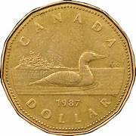
On June 30, 1987, Canada officially introduced the new one-dollar circulation coin nicknamed the Loonie. The 11-sided bronze-colored coin depicted a common loon on the reverse, designed by Canadian wildlife artist Robert-Ralph Carmichael. (https://www.mint.ca/en-us)
Originally, a Voyageur design was intended for this new coin, but the dies were lost in transit to the minting facility — triggering the use of the loon design instead. (https://www.mint.ca/en-us)
Why “Loonie”?
The term “Loonie” quickly became popular because of the loon on the coin and was soon applied colloquially to both the coin and the Canadian dollar itself. The Royal Canadian Mint later even trademarked the name. (Wikipedia)
Phase-Out of the Dollar Note
The Canadian one-dollar bill continued circulating alongside the new coin until 1989, when it was officially withdrawn from circulation. (rcinet.ca)
Design Evolution
Over the years, the Loonie has featured various commemorative designs celebrating national events, anniversaries, and figures, while retaining the loon motif as its iconic hallmark. (https://www.mint.ca/en-us)
Additionally, modern Loonies now include advanced security features, such as a micro-engraved maple leaf laser mark, to help prevent counterfeiting. (https://www.mint.ca/en-us)

Legacy and Cultural Impact
Today, the Loonie is more than just currency — it’s a symbol of Canadian identity and craftsmanship. Its introduction marked one of the most significant changes to Canadian coinage in decades and reflects both practical and cultural considerations in national money design. (https://www.mint.ca/en-us)

Timeline of Canadian $1 Coins — Mintages, Compositions & Portraits
Year(s) | Coin Type / Issue | Approx. Mintage | Composition | Obverse Portrait
Pre-1858 | Foreign dollars circulating in British North America (Spanish, U.S., etc.) | N/A | Silver (varied) | Foreign rulers
1858–1870 | Canadian decimal coinage introduced (no $1 coin yet) | N/A | — | Queen Victoria
1911 | Pattern Silver Dollar (never circulated) | 3 known (2 silver, 1 lead) | 92.5% silver | King George V
1935 | First circulating Canadian $1 (Voyageur) | 1,010,710 | 80% silver | King George V
1936–1952 | Voyageur silver dollars (regular issues) | Varies by year | 80% silver | King George V / King George VI
1939 | Royal Visit commemorative dollar | ~1,000,000 | 80% silver | King George VI
1949 | Newfoundland Confederation dollar | ~1,000,000 | 80% silver | King George VI
1953–1964 | Voyageur silver dollars | Varies by year | 80% silver | Queen Elizabeth II (Young Head)
1964 | Charlottetown & Québec Conferences dollar | ~7,300,000 | 80% silver | Queen Elizabeth II
1967 | Centennial “Flying Goose” dollar | ~21,000,000 | 50% silver / 50% copper | Queen Elizabeth II
1968–1986 | Nickel Voyageur dollars | Tens of millions total | 99.9% nickel | Queen Elizabeth II
1987 | Loonie introduced | ~187,000,000 | Bronze-plated nickel | Queen Elizabeth II
1989 | $1 banknote withdrawn | — | — | —
1990–2002 | Standard Loonie issues | Varies annually | Bronze-plated nickel | Queen Elizabeth II
2003–2022 | Modern Loonies (security enhancements) | Varies annually | Brass-plated steel | Queen Elizabeth II
2023–Present | Loonie with King Charles III portrait | Ongoing | Brass-plated steel | King Charles III

References
- Royal Canadian Mint, Striking in its Solitude – the 1-dollar Coin (history and designs). (https://www.mint.ca/en-us)
- Bank of Canada Museum, The 1911 Silver Dollar. (bankofcanadamuseum.ca)
- Royal Canadian Mint blog, A Tale of Two Designs: How Canada’s 1-dollar Coin Became the Loonie. (https://www.mint.ca/en-us)
- Wikipedia, Loonie. (Wikipedia)
- Wikipedia, Voyageur dollar. (Wikipedia)
- Wikipedia, Canadian silver dollar. (Wikipedia)
- The Canadian Encyclopedia, Canadian Dollar (CAD). (thecanadianencyclopedia.ca)

Jim Austin collects coins, paper currency, wood money and tokens. He enjoys writing about Numismatic topics; particularly Canadian ones.
He is a member of the Ontario Numismatic Assoc., The Canadian Association of Wooden Money Collectors, and is currently president of his local coin club. . Jim owns and operates AustinCoins.ca.
You may use this article in it’s entirety in your blog or newsletter, as long as you include this authors reference box and include a link back to AustinCoins.ca

