Provincial Shinplaster Issues in Canada
By Jim Austin
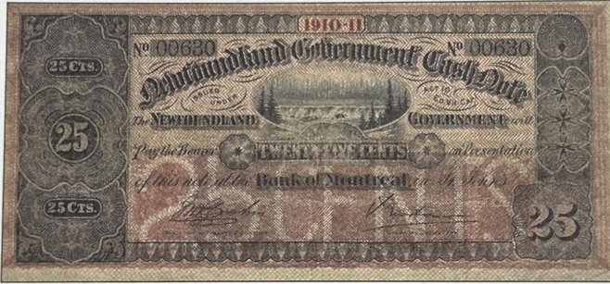

While the Dominion of Canada government was the principal issuer of shinplaster notes, the practice of printing fractional currency was not entirely confined to the federal level. In the decades before Confederation in 1867, several Canadian provinces—then known as
British North American colonies—issued their own forms of low-denomination paper money that would later be colloquially categorized as shinplasters.

Which Provinces Printed Their Own Shinplasters?
The provinces of New Brunswick, Nova Scotia, and Prince Edward Island are noteworthy for issuing their own fractional notes during the mid-19th century. These notes typically ranged in value from 5 cents to 50 cents. Such provincial shinplasters were most commonly issued between the 1830s and 1860s, prior to the unification of Canadian currency under the Dominion government.[2]

When Were Provincial Shinplasters Printed?
- New Brunswick: Issued fractional notes from the 1830s through the 1860s.
- Nova Scotia: Printed low-value notes intermittently from the 1840s to the 1860s.
- Prince Edward Island: Produced its own shinplasters, especially in the 1840s and 1850s.
Other provinces, such as Newfoundland, also printed fractional paper currency before joining Canada, although these are not always referred to as shinplasters in the strictest sense. Their issues continued into the late 19th and early 20th centuries.
(continued on page 8)

Why Did Provinces Issue Shinplaster Notes?
Several factors motivated the provinces to issue their own shinplaster notes. Chief among them was a persistent shortage of coins for everyday transactions. The remote location of some regions, the slow supply of British and foreign coinage, and fluctuations in the colonial economy made small change hard to come by. Provincial governments and local banks stepped in to fill this void by issuing their own small-denomination notes, ensuring commerce could continue smoothly. These notes were typically intended for local circulation, and their designs often reflected regional symbols or figures of importance.[2][4]

Legacy
When the Dominion of Canada standardized the currency system after Confederation, most provincial shinplaster issues were withdrawn from circulation in favor of nationally issued notes. Collectors today value surviving examples of these provincial shinplasters for their historical and regional significance, as they represent an important chapter in the evolution of Canadian money.

References
- Bank of Canada Museum. "Shinplasters: Canada’s 25-Cent Notes." bankofcanadamuseum.ca
- The Canadian Encyclopedia. "Shinplaster." thecanadianencyclopedia.ca
- Banknote World. "Canada 25 Cents, Shinplaster Notes." banknoteworld.com
- Canadian Currency Exhibit. "Dominion of Canada Fractional Notes." currency.museum.ca

Jim Austin collects coins, paper currency, wood money and tokens. He enjoys writing about Numismatic topics; particularly Canadian ones.
He is a member of the Ontario Numismatic Assoc., The Canadian Association of Wooden Money Collectors, and is currently president of his local coin club. . Jim owns and operates AustinCoins.ca.
You may use this article in it’s entirety in your blog or newsletter, as long as you include this authors reference box and include a link back to AustinCoins.ca

