Edge Lettering on Canadian Toonies Since 2012

By Jim Austin

Canada’s Two-Dollar Coin — The Toonie

What Changed in 2012: Edge Lettering
Starting in 2012, the Royal Canadian Mint updated its circulation coins — including the $2 Toonie — to add advanced anti-counterfeiting security features:

New Security Features
- Edge lettering with the text “CANADA” and “2 DOLLARS” engraved around the rim.
- Laser-engraved maple leaf marks in the design.
- A latent image that shifts when the coin is tilted.
- Interrupted reeding (a mix of smooth and ridged sections) on their edges — a tactile pattern to aid identification.

Why Edge Lettering Was Added
Edge lettering improved security and usability:
- Anti-Counterfeiting: Text and symbols on the edge are harder for counterfeiters to duplicate without precise equipment.
- Modern Identification: The clear denomination and country name on the edge help devices and humans confirm authenticity.
- Integrated Security Design: The lettering complements laser marks and latent imagery for layered protection.

Type A vs. Type B Edge Lettering — Close-Up Views
Because the edge lettering process is separate from the main coin strike, each coin can enter the edge press obverse-up or reverse-up. This random entry produces two orientation varieties:

Type A Edge Lettering

Letters read correctly (upright) when the obverse (Queen’s or Kings’s portrait) is facing up.
- Often shown by collectors as the standard presentation.

Type B Edge Lettering
- Letters read upside down when the obverse is facing up.
- Same coin otherwise; just rotated differently during edge tooling.
Below is real example showing the obverse being up — which affect how the edge lettering will appear on either type:
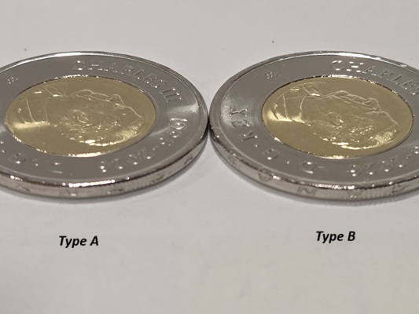
Note: These images show the faces (obverse) of toonies. Collectors view the edge lettering direction relative to the obverse orientations to classify a coin as Type A or Type B.

How Many Varieties Are There?
In terms of edge lettering orientation, there are two varieties for each edge-lettered toonie:
- Type A — Lettering upright when obverse side is shown.
- Type B — Lettering upright when reverse side is shown.
These are not separate official issues — just natural varieties created by how coins enter the edge lettering press. Collectors often seek both orientations, but they are functionally the same denomination and design otherwise.

Other Notes on Edge Lettering
- Some coins may show slight dimples or rim marks where the edge lettering press impacted the coin. This is a by-product of the process, not damage.
- Rare error coins or missing-lettering variants (if produced) are extremely collectible but uncommon.

So What Does This Mean For The Collector?
- Basically, it depends on the individual collector. How deep they go with their collection.
- If you only want the basics, just collect one of each coin; irregardless of type.
- If you look for or want varieties, then you may want to have one each of the Type A and the Type B Toonie.
- There is no right or wrong way to collect coins.

References
- Royal Canadian Mint: Specifications and security features of the $2 Toonie, including edge lettering. Royal Canadian Mint
- Saskatoon Coin Club: Documentation on Type A vs. Type B edge lettering varieties. Saskatoon Coin Club
- Collector discussions & observations on how edge lettering appears depending on coin orientation. Numista
Jim Austin collects coins, paper currency, wood money and tokens. He enjoys writing about Numismatic topics; particularly Canadian ones.
He is a member of the Ontario Numismatic Assoc., The Canadian Association of Wooden Money Collectors, and is currently president of his local coin club. . Jim owns and operates AustinCoins.ca.
You may use this article in it’s entirety in your blog or newsletter, as long as you include this authors reference box and include a link back to AustinCoins.ca

