Canadian Shinplaster Notes: History, Production, and Designs
A Comprehensive Look at Canada's Small-Denomination Currency
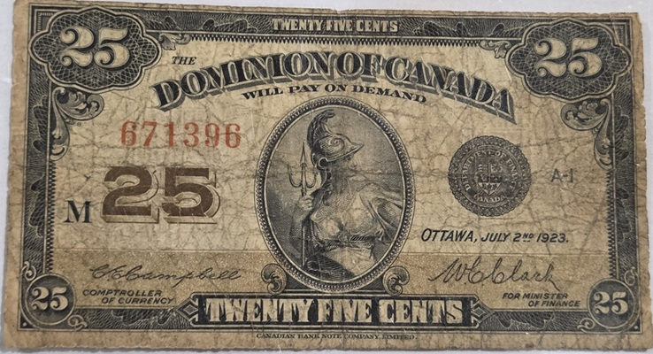
By Jim Austin

Introduction
Canadian Shinplaster notes hold a unique place in the history of Canadian currency. Serving as low-denomination paper money, these notes were essential for everyday transactions during a time when coins were scarce. This article explores where and why Shinplaster notes were printed, the years of their production, their quantity, and the distinctive designs that made them memorable.[1][2]

Where Were Shinplaster Notes Printed?
Shinplaster notes were printed in Canada by the Dominion of Canada government. The actual printing took place primarily in Ottawa, which was the administrative and political center for currency production during the late 19th and early 20th centuries.[1][3]

Why Were Shinplaster Notes Printed?
The term "shinplaster" originated in the United States and referred to small denomination, low-value paper currency. In Canada, these notes emerged out of necessity. During the late 1800s, there was a shortage of silver coins, making it difficult for Canadians to conduct everyday transactions. To address this, the government issued fractional currency notes, most commonly in the 25-cent denomination, to substitute for missing coins and facilitate commerce.[1][4]

Years of Production
The official Canadian Shinplaster notes were printed over three main periods:
- First Issue: 1870
- Second Issue: 1900
- Third Issue: 1923
Each issue addressed ongoing shortages of coinage and reflected changes in design and security features over time.[1][2]

How Many Shinplaster Notes Were Printed?
The exact quantity of Shinplaster notes printed varied by issue. For the initial 1870 issue, millions of notes were produced to address the immediate shortage. By the 1923 issue, the number had grown considerably due to increased demand and population growth. Estimates suggest that over 50 million Shinplaster notes were printed across all issues. However, many have since been lost or destroyed, making surviving specimens collectible today.[2][3]

Designs on the Shinplaster Notes
The designs of Canadian Shinplaster notes
evolved over time, reflecting both artistic trends and practical concerns such as counterfeit prevention.
- 1870 Issue: Featured a vignette of Britannia seated with a trident and shield, symbolizing strength and protection. The note included ornate borders and fine detailing.
- 1900 Issue: Showcased the portrait of Princess Patricia of Connaught, a member of the British royal family. The note included intricate scrollwork and security features.
- 1923 Issue: Depicted a young woman known as "Miss Canada," surrounded by elaborate patterns and borders. The note was designed to be visually striking and difficult to counterfeit.
Common to all issues were design elements such as bilingual text (English and French), serial numbers, and the official seal of the Dominion of Canada. The notes were small in size, which made them easy to carry and earned them the informal nickname "shinplasters."[1][4]

Conclusion
Canadian Shinplaster notes are a fascinating part of Canada's monetary history. Printed in Ottawa to address coin shortages between 1870 and 1923, more than 50 million notes were issued. Their designs ranged from Britannia and royal figures to allegorical representations of Canada, making them not only practical but also culturally significant. Today, surviving Shinplaster notes are prized by collectors and serve as reminders of a formative period in Canadian currency.[1][2][3][4]

References
- Bank of Canada Museum. "Shinplasters: Canada’s 25-Cent Notes." bankofcanadamuseum.ca
- The Canadian Encyclopedia. "Shinplaster." thecanadianencyclopedia.ca
- Banknote World. "Canada 25 Cents, Shinplaster Notes." banknoteworld.com
(continued on page 7)
- Canadian Currency Exhibit. "Dominion of Canada Fractional Notes." currency.museum.ca

Jim Austin collects coins, paper currency, wood money and tokens. He enjoys writing about Numismatic topics; particularly Canadian ones.
He is a member of the Ontario Numismatic Assoc., The Canadian Association of Wooden Money Collectors, and is currently president of his local coin club. . Jim owns and operates AustinCoins.ca.
You may use this article in it’s entirety in your blog or newsletter, as long as you include this authors reference box and include a link back to AustinCoins.ca

